**Abstract**

A unit conversion expresses the same property as a different unit of measurement. For instance, time can be expressed in minutes instead of hours, while distance can be converted from miles to kilometers, or feet, or any other measure of length. Often measurements are given in one set of units, such as feet, but are needed in different units, such as chains. A conversion factor is a numeric expression that enables feet to be changed to chains as an equal exchange.

A conversion factor is a number used to change one set of units to another, by multiplying or dividing. When a conversion is necessary, the appropriate conversion factor to an equal value must be used. For example, to convert inches to feet, the appropriate conversion value is 12 inches equal 1 foot. To convert minutes to hours, the appropriate conversion value is 60 minutes equal 1 hour.  
  
A unit cancellation table is developed by using known units, conversion factors, and the fact that a unit of measure ÷ the same unit of measure cancels out that unit. The table is set up so all the units cancel except for the unit desired. To cancel a unit, the same unit must be in the numerator and in the denominator. When you multiply across the table, the top number will be divided by the bottom number, and the result will be the answer in the desired units

The project provides the following functions:-

**1. Taking various inputs of variable Size:**

**2. Converting Inputed Units into desired Units:**

**3. Displaying the converted records:**

**Machine & Software**

In recent time, the use of Computers especially personal computer or PC’s has revolutionized the approach of system management and data storage. The popularity of using computers has also decreases cost. The verities of Computer resources is collectively called *Hardware (H/W)* and computer also equipped with complementary product (Programs) that are collectively called *Software(S/W)*.

# H/W Configuration

Processor : Ryzen 3 1300X Quad-Core 3.80Ghz

Temporary Storage (RAM) : 8 GB

Permanente Storage : 1TB Hard Disk, 128gb SSD

# S/W Configuration

Operating System : Windows 10 Pro

Programming Language : Python 3.7

MAIN CODE

#**Unit converter system**

from tkinter import*

from tkinter import ttk

from tkinter.ttk import Combobox

import tkinter.font as tkFont

master=Tk()

master.geometry("750x320")

fontStyle = tkFont.Font(family="Lucida Grande", size=20 )

w = Label(master, text="Unit Converter System" ,font=fontStyle)

w.grid(row=0, column=0)

frame1=LabelFrame(master ,text="LENGTH CONVERTER",width=650, height=750, borderwidth = 5,padx=10,pady=30,bg="#FF7F50",font="3")

frame1.grid(row=1, column=0)

LengthData=("Centimetre to metre", "milimetre to Centimetre","Metre to Centimetre","Centimetre to Milimetre","Milimetre to Metre ","Metre to MilliMetre ","KiloMetre to Metre ",

"Metre to KiloMetre","MilliMetre to KiloMetre ","Metre to CentiMetre","Feet to Milimetre","Feet to CentiMetre","Feet to Inches","Inches to CentiMetre","Inches to MilliMetre")

frame2=LabelFrame(master ,text="WEIGHT CONVERTER",width=650, height=750, borderwidth = 5,padx=10,pady=30,bg="#FF7F50",font="3")

frame2.grid(row=2, column=0)

WeigthData=("Pounds to Kilograms"," Kilograms to Pounds","Kilograms to Grams","Grams to Kilograms","Pounds to Grams","Grams to Pounds")

t1Insert = IntVar()

t1data = StringVar()

t1Entry = Entry(frame1, textvariable=t1Insert,font="3",bg="#ADFF2F").grid(row=3, column=0)

t1menu=OptionMenu(frame1,t1data, *LengthData)

t1menu.config(width=25,font="3",bg="#DDA0DD")

t1data.set('Select Choice')

t1menu.grid(row=3, column=1)

L1 = Label(frame1, text="Output = ____ ",font="3",bg="#87CEFA")

L1.grid(row=3, column=5)

b1 = Button(frame1, text='Convert', width=15,command=lambda:length_converter(),bg="#90EE90",font="3")

b1.grid(row=3, column=3)

t2Insert = IntVar()

t2data = StringVar()

t2Entry = Entry(frame2, textvariable=t2Insert,font="3",bg="#ADFF2F").grid(row=3, column=0)

t2menu=OptionMenu(frame2,t2data, *WeigthData)

t2menu.config(width=25,font="3",bg="#DDA0DD")

t2data.set('Select Choice')

t2menu.grid(row=3, column=1)

L2 = Label(frame2, text="Output = ____ ",font="3",bg="#87CEFA")

L2.grid(row=3, column=5)

b2 = Button(frame2, text='Convert', width=15,command=lambda:weight_converter(),bg="#90EE90",font="3")

b2.grid(row=3, column=3)

def length_converter():

num1 = float(t1Insert.get())

list1data=t1data.get()

if list1data=="Centimetre to metre":

ans = float(num1)/100

L1 = Label(frame1, text="Output = "+str(ans),bg="#90EE90",font="3")

L1.grid(row=3, column=5,padx=50)

elif list1data=="milimetre to Centimetre":

ans = float(num1)/10

L1 = Label(frame1, text="Output = "+str(ans),bg="#90EE90",font="3")

L1.grid(row=3, column=5)

elif list1data=="Metre to Centimetre":

ans = float(num1)*100

L1 = Label(frame1, text="Output = "+str(ans),bg="#90EE90",font="3")

L1.grid(row=3, column=5)

elif list1data=="Centimetre to Milimetre":

ans = float(num1)*10

L1 = Label(frame1, text="Output = "+str(ans),bg="#90EE90",font="3")

L1.grid(row=3, column=5)

elif list1data=="Milimetre to Metre":

ans = float(num1)/1000

L1 = Label(frame1, text="Output = "+str(ans),bg="#90EE90",font="3")

L1.grid(row=3, column=5)

elif list1data=="Metre to MilliMetre":

ans = float(num1)*1000

L1 = Label(frame1, text="Output = "+str(ans),bg="#90EE90",font="3")

L1.grid(row=3, column=5)

elif list1data=="KiloMetre to Metre":

ans = float(num1)*1000

L1 = Label(frame1, text="Output = "+str(ans),bg="#90EE90",font="3")

L1.grid(row=3, column=5)

elif list1data=="Metre to KiloMetre":

ans = float(num1)/1000

L1 = Label(frame1, text="Output = "+str(ans),bg="#90EE90",font="3")

L1.grid(row=3, column=5)

elif list1data=="MilliMetre to KiloMetre":

ans = float(num1)/1000000

L1 = Label(frame1, text="Output = "+str(ans),bg="#90EE90",font="3")

L1.grid(row=3, column=5)

elif list1data== "Feet to CentiMetre":

ans = float(num1)*30.48

L1 = Label(frame1, text="Output = "+str(ans),bg="#90EE90",font="3")

L1.grid(row=3, column=5)

elif list1data=="Feet to Milimetre":

ans = float(num1)*304.8

L1 = Label(frame1, text="Output = "+str(ans),bg="#90EE90",font="3")

L1.grid(row=3, column=5)

elif list1data=="Feet to Inches":

ans = float(num1)*12

L1 = Label(frame1, text="Output = "+str(ans),bg="#90EE90",font="3")

L1.grid(row=3, column=5)

elif list1data=="Inches to CentiMetre":

ans = float(num1)*2.54

L1 = Label(frame1, text="Output = "+str(ans),bg="#90EE90",font="3")

L1.grid(row=3, column=5)

elif list1data=="Inches to MilliMetre":

ans = float(num1)*25.4

L1 = Label(frame1, text="Output = "+str(ans),bg="#90EE90",font="3")

L1.grid(row=3, column=5)

def weight_converter():

num1 = float(t2Insert.get())

list2data=t2data.get()

if list2data=="Pounds to Kilograms":

ans = float(num1)/2.2046

L2 = Label(frame2, text="Output = "+str(ans),bg="#90EE90",font="3")

L2.grid(row=3, column=5)

elif list2data=="Kilograms to Pounds":

ans = float(num1)*2.2046

L2 = Label(frame2, text="Output = "+str(ans),bg="#90EE90",font="3")

L2.grid(row=3, column=5)

elif list2data=="Kilograms to Grams":

ans = float(num1)*1000

L2 = Label(frame2, text="Output = "+str(ans),bg="#90EE90",font="3")

L2.grid(row=3, column=5)

elif list2data=="Grams to Kilograms":

ans = float(num1)/1000

L2 = Label(frame2, text="Output = "+str(ans),bg="#90EE90",font="3")

L2.grid(row=3, column=5)

elif list2data=="Pounds to Grams":

ans = float(num1)/0.0022046

L2 = Label(frame2, text="Output = "+str(ans),bg="#90EE90",font="3")

L2.grid(row=3, column=5)

elif list2data=="Grams to Pounds":

ans = float(num1)*0.0022046

L2 = Label(frame2, text="Output = "+str(ans),bg="#90EE90",font="3")

L2.grid(row=3, column=5)

**Output Screen**

**Main Menu:**

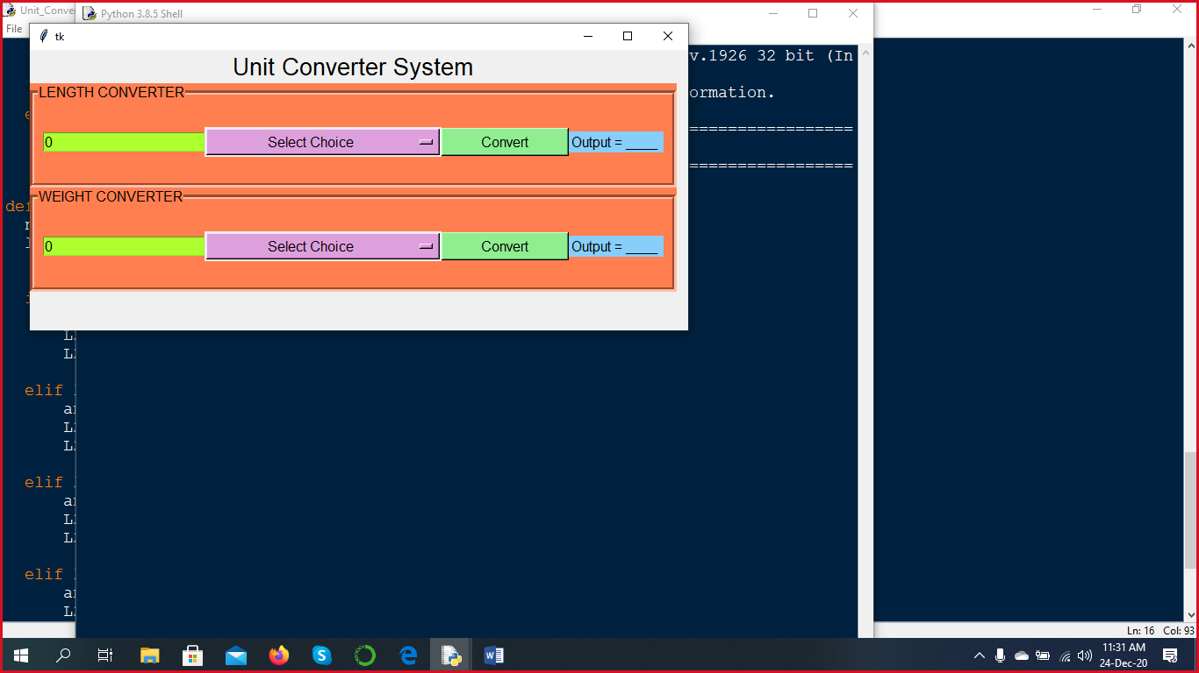

**Testing**

1. **Testing Length Converter**

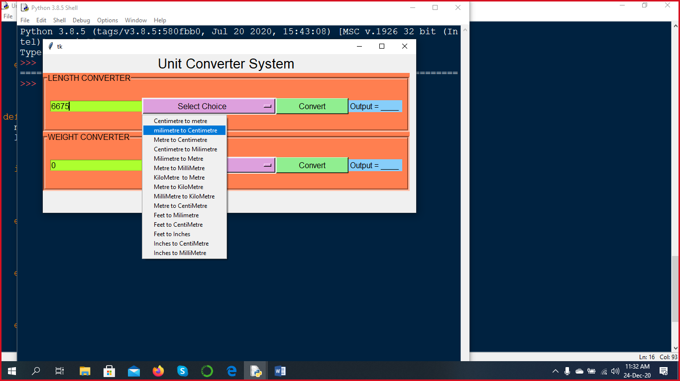

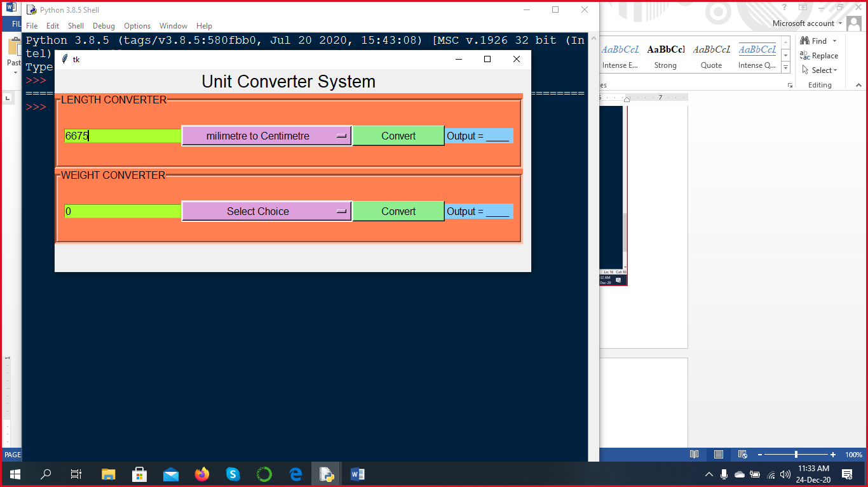

**Now click on Convert Button**

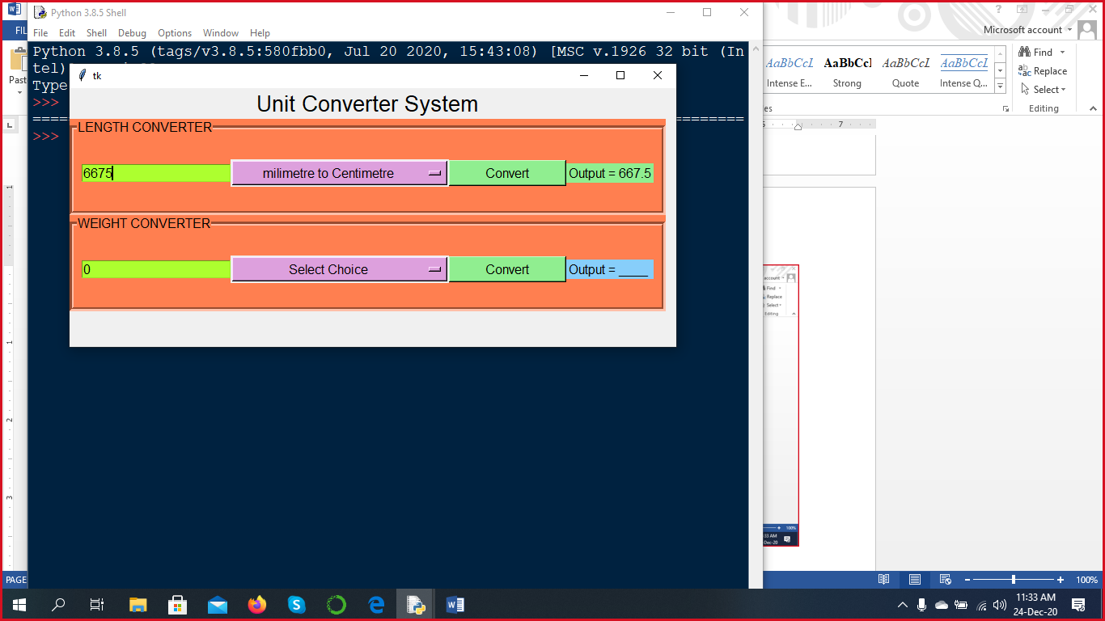

1. **Testing weight Converter**

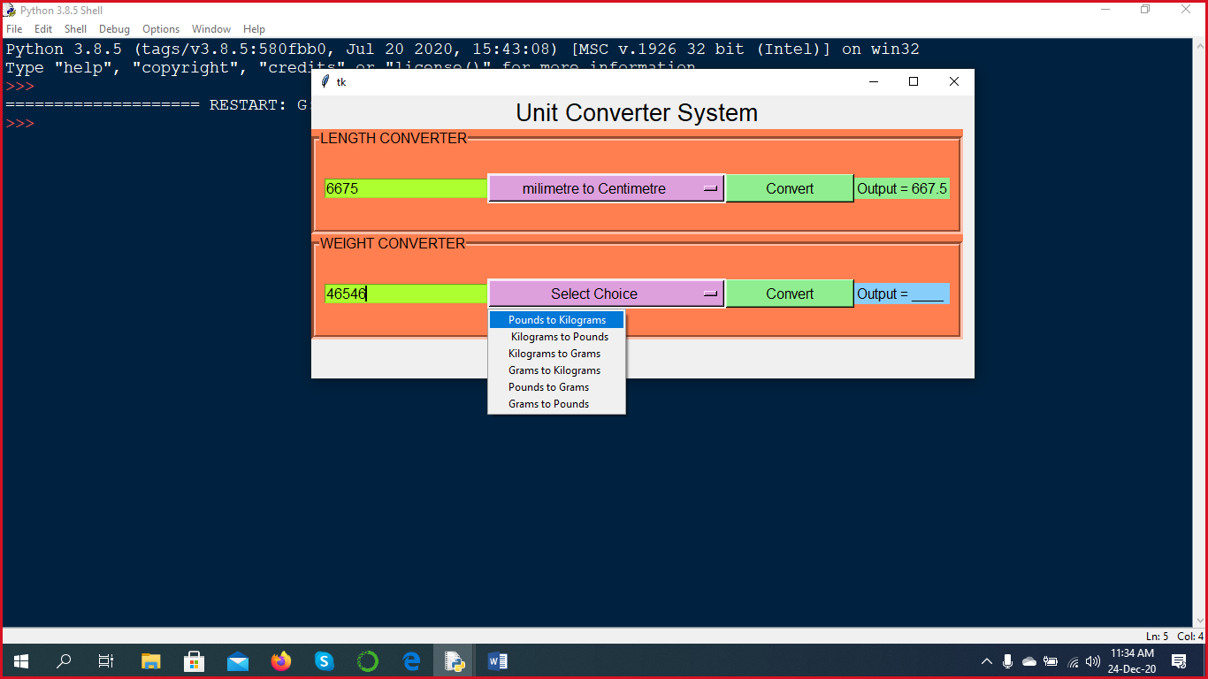

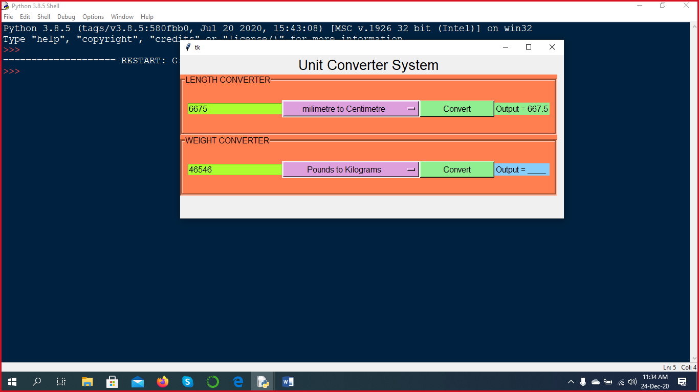

**Now click on Convert Button**

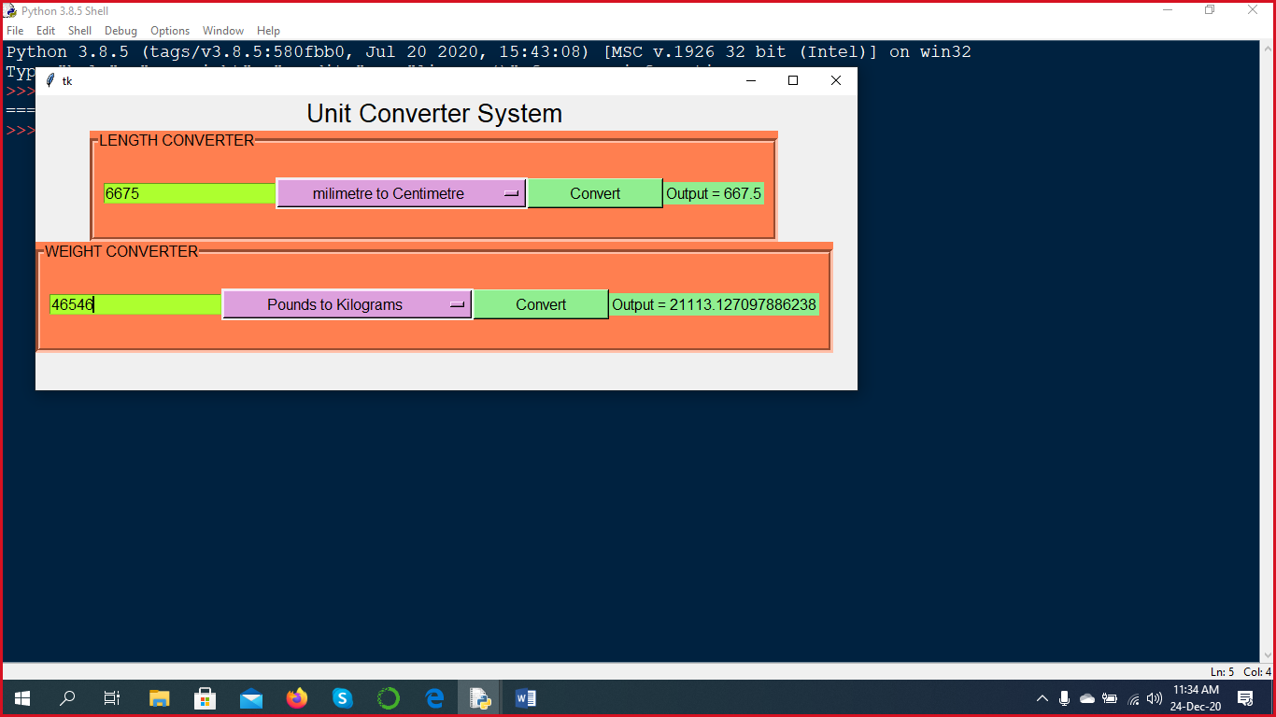

**Conclusion and Future Work**

A simple stand-alone project has been presented. This projects not at all a complete one. The project depicts only some basic operation that are the part of any unit converter system. We are not claiming that developed program is completely error free. There could be some drawbacks which may be revealed during the later stages of checking.

**Bibliogrphy**

1. “Informatics Practices for class XI” by S. Arora ISBN : 978-81-7700-232-4
2. “Informatics Practices for class XII” by S. Arora ISBN : 978-81-7700-237-9

Thank you